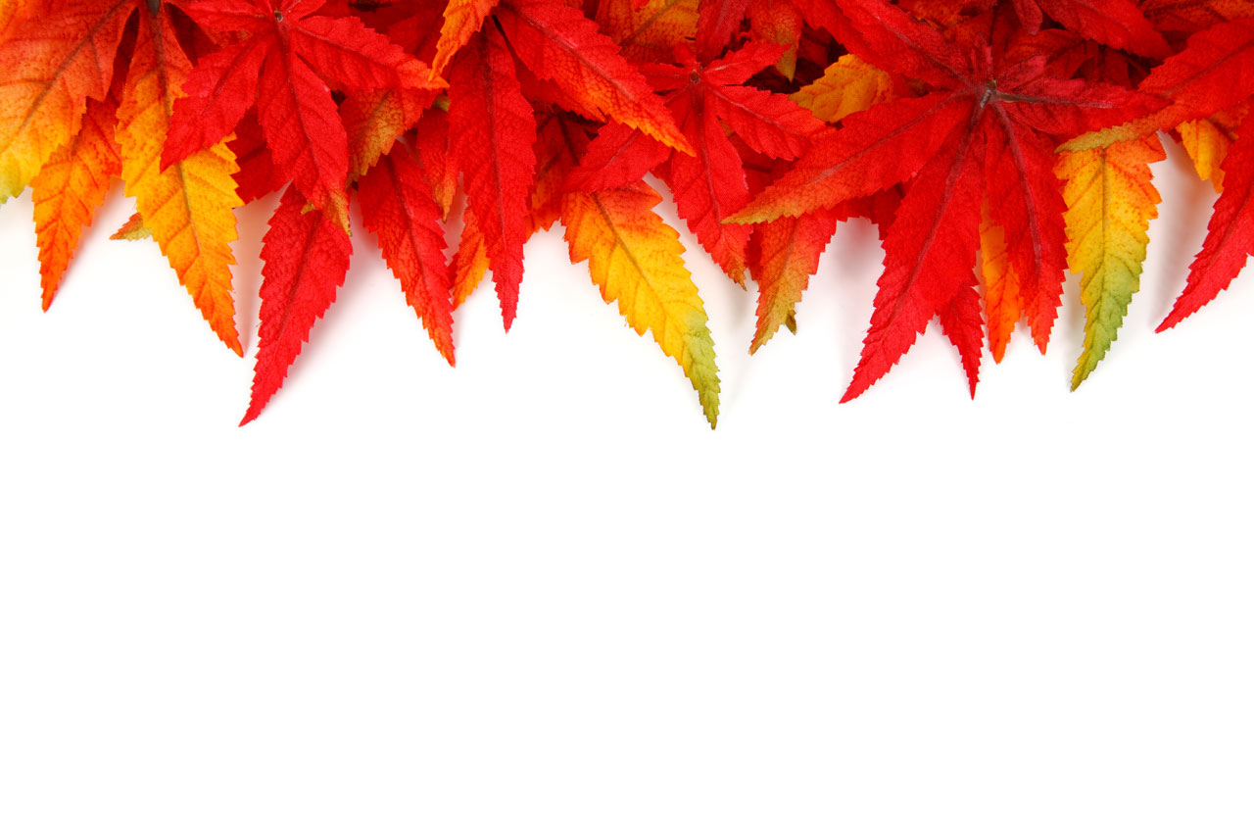

MEAD ELEMENTARY PTSA

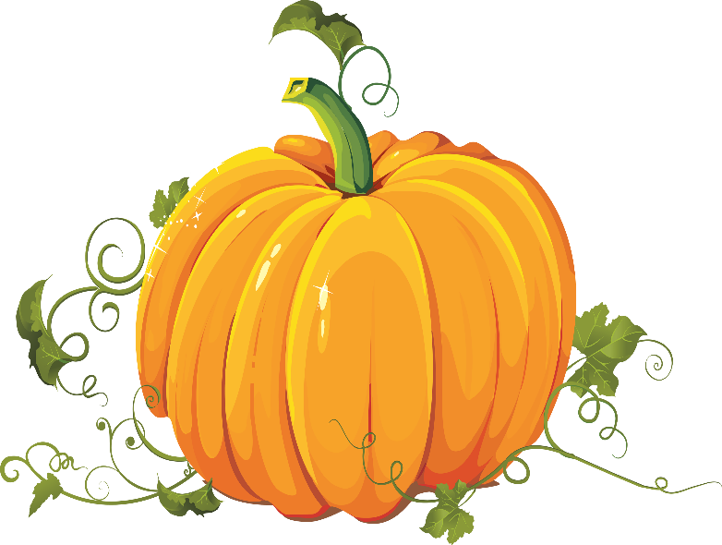

This Photo by Unknown Author is licensed under CC BY-NC

**PUMPKIN DECORATING CONTEST**

Pumpkins can be carved, painted, or decorated in any way that inspires you! Use your imagination, have FUN and show us your Halloween SPIRIT!!

**How to Enter:**

Take a picture of your decorated pumpkin, give it a title & description, and email to: engagement@meadptsa.org

* ONE entry per student, please!

**Prizes will be awarded for:**

* Best in Show Pumpkin**
* Most Creative Pumpkin
* Silliest Pumpkin
* Spookiest Pumpkin

**Best in Show Pumpkin will receive a gift card to custom order Mead Spirit Wear!

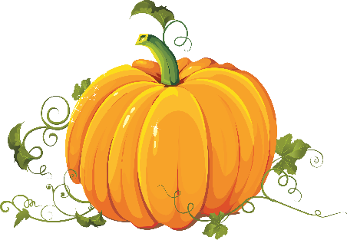

This Photo by Unknown Author is licensed under CC BY-NC

Winners will be announced on

Friday October 30th

All entries need to be submitted by:

October 26, 2020